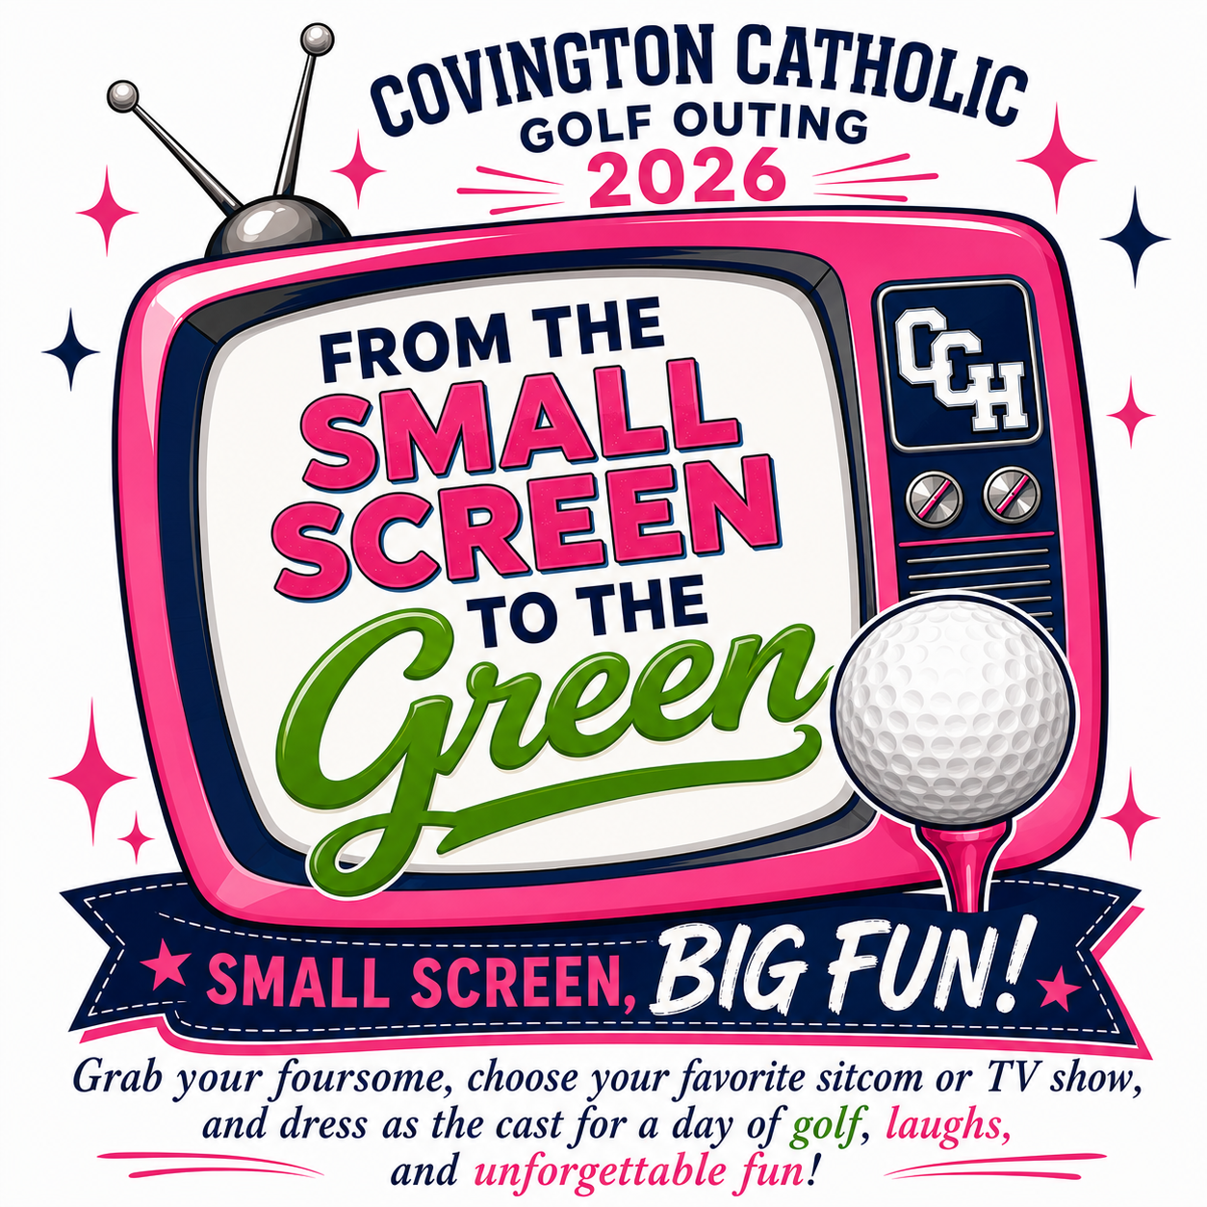
LADIES GOLF OUTING
HOLE SPONSORSHIP FORM 2026

Name: ___________________________________________________
Company/business name: (To be printed on outing signage)
______________________________________________________________________________________________________________________________________________________________________________
Phone #: _________________________________________________
Hole Sponsorship: $100

Please make check payable to Covington Catholic Parents Club and mail to:
Covington Catholic Attn: Ladies Golf Outing 1600 Dixie Highway Park Hills Ky 41011
Your company logo (if applicable) should be emailed in JPEG form by 9/1/26.
For any questions, please contact Kara Disibio at KDisibio@covcath.org or
Moreen Nienaber at moreen.nienaber@gmail.com
THANK YOU SO MUCH FOR YOUR SUPPORT!

