FOR IMMEDIATE RELEASE  January 28, 2016 | 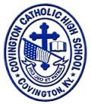
CONTACT:
Jill Franxman
Director of Business Operations & Marketing
Phone: (859) 448-2253
Email: jfranxman@covcath.org
Website: www.covcath.org
Facebook: www.facebook.com/CovCath

Covington Catholic High School Announces
New Scholarship Recognizing Pro-Life Student

Covington Catholic High School announces a new $1,000 scholarship award provided by the Dr. Jerome & Marianne Schutzman Scholarship Fund. The award was presented today to Coire Ayres, a senior at Covington Catholic, in recognition of his pro-life activities.

With this scholarship, the Schutzmans wanted to encourage the importance of religion and character, with a specific emphasis on pro-life. They requested that the scholarship be awarded and announced in January (Pro-life month). Coire was surprised with the news of his selection during class today when Principal Mr. Bob Rowe, religion teacher and Colonels for Life club moderator Mr. Rich Andolina, and Director of Advancement Ms. Judy See arrived at his class to announce his selection for the award.

Mr. Andolina said of Coire’s selection: “Coire is at the top of my list. He has consistently demonstrated to me his desire and willingness to participate in pro-life activities.”

Coire is the son of Matt and Stacey Ayres of Fort Mitchell, Kentucky. They are members of St. Agnes parish.

Covington Catholic High School is a Blue Ribbon of Excellence award winning college preparatory high school located in Park Hills, Kentucky. It is an all-male school of 604 whose mission is to embrace the Gospel message of Jesus Christ in order to educate students spiritually, academically, physically and socially.

# # #
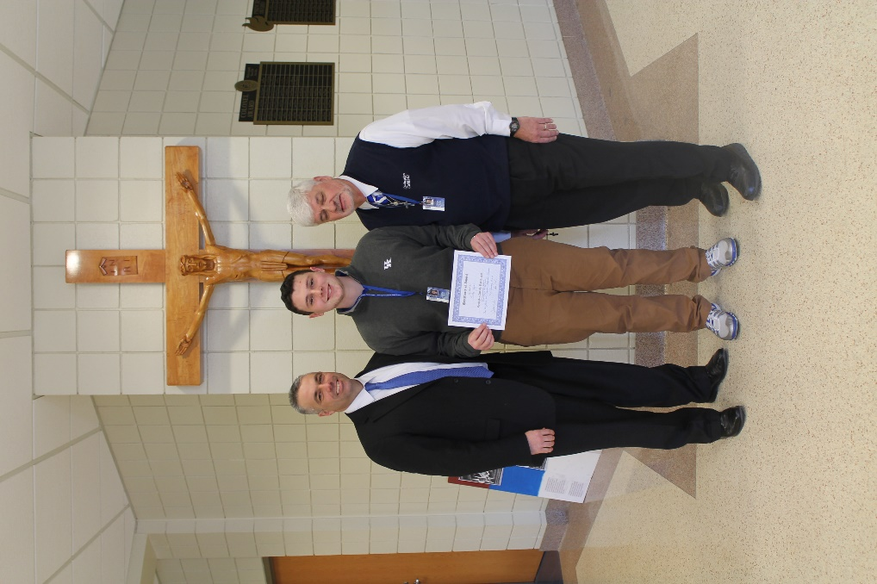
Mr. Bob Rowe, Senior Coire Ayers and Mr. Rich Andolina

