FOR IMMEDIATE RELEASE  December 5, 2016 | 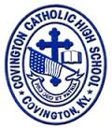
CONTACT:
Jill Franxman
Director of Marketing & Communications
Phone: (859) 448-2253
Email: jfranxman@covcath.org
Website: www.covcath.org
Facebook: www.facebook.com/CovCath

COVCATH TO HOST THE 2ND ANNUAL COLONEL CLASSIC
ROBOTICS TOURNAMENT ON SATURDAY, JANUARY 7, 2017

Covington Catholic High School will host the 2nd Annual Colonel Classic Robotics Tournament at the Covington Catholic High School gymnasium at 1600 Dixie Highway in Park Hills, KY, on Saturday, January 7, 2017.

As many as 50 middle school and high school teams are expected to compete in the “VEX Robotics Competition” event. It is the first VEX event in Kentucky for 2017 and begins the home stretch to the State and World VEX Tournament. At least 5 teams will qualify at this event for the Kentucky state tournament in the spring.

VEX Robotics competitions are presented by the Robotics Education & Competition Foundation.
From www.vexrobotics.com: “In the VEX Competitions, teams of students are tasked with designing and building a robot to play against other teams in a game-based engineering challenge. Classroom STEM concepts are put to the test on the playing field as students learn lifelong skills in teamwork, leadership, communications, and more. Tournaments are held year-round at the regional, state, and national levels; local champions go on to compete against the best in the world at VEX Worlds each April!”

A Covington Catholic Robotics team competed in the 2016 World event, which produced a world record as the largest robotics tournament, with 500 teams in the high school division. CovCath’s ten matches included teams from the US, Taiwan, Colombia, and Mexico.

The 2016-17 VEX competition is called Starstruck (more info at: https://youtu.be/0t2zstQ84Tw).

The schedule for the CovCath Colonel Classic Robotics Tournament on January 7, 2017, is:

7:30 am Doors Open
8:00 am Inspection Begins and skill runs can be done after inspection
9:00 am Drivers Meeting
9:30 am Event Qualifying Begins
2:30 pm Event Alliance Selection
3:00 pm Tournament Starts
4:30 pm Event Ends

Spectators are welcome; the event is free and open to the public.

For more information, please contact Mr. Bob Lind (STEM Director, Robotics/Engineering Club Moderator, and Teacher at Covington Catholic) at blind@covcath.org.

Covington Catholic High School is a 2016 National Blue Ribbon School and college preparatory high school within the Diocese of Covington. It is an all-male school of 597 whose mission is to embrace the Gospel message of Jesus Christ in order to educate students spiritually, academically, physically and socially.

# # #

Photo 1: Members of Covington Catholic Robotics teams at a tournament this fall.

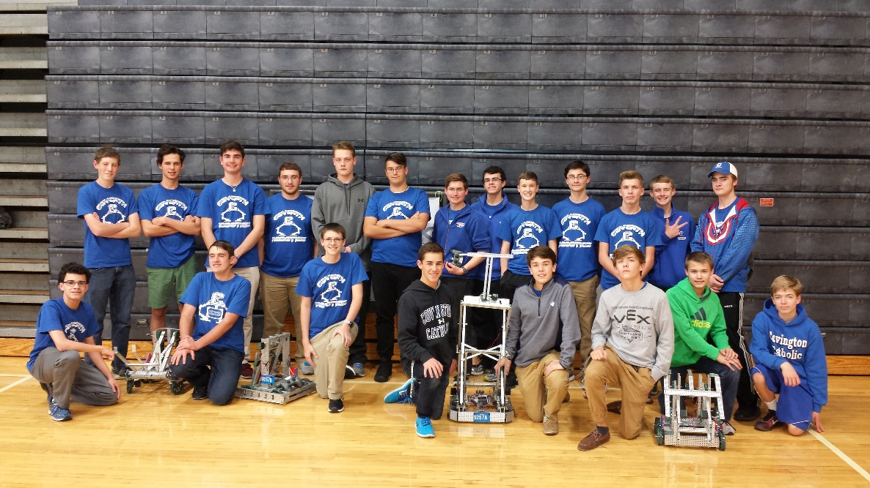

Photo 2: A Covington Catholic team competed in the 2016 VEX World Championships in Louisville, KY, in April, 2016.

