FOR IMMEDIATE RELEASE  February 10, 2016 | 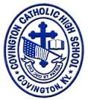
CONTACT:
Jill Franxman
Director of Business Operations & Marketing
Phone: (859) 448-2253
Email: jfranxman@covcath.org
Website: www.covcath.org
Facebook: www.facebook.com/CovCath

COVINGTON CATHOLIC HIGH SCHOOL
ANNOUNCES SEVEN NATIONAL MERIT FINALISTS

Covington Catholic, a Blue Ribbon School, is proud to announce that seven seniors have been recognized by the National Merit Scholarship Corporation as Finalists in the 61st annual National Merit® Scholarship Program. This total of seven is the most of any high school (public or private) in Northern Kentucky.
Last spring, roughly 1.5 million juniors in more than 22,000 high schools across the country entered the 2016 program by taking the PSAT/NMSQT Qualifying Test. Of those juniors, only 16,000, or about 1%, were named National Merit Semifinalists, based on their scores on this exam. Finalists, named from among these academically talented students, will advance one step further in the competition for some 7,400 scholarships worth more than $32 million, to be awarded in the spring of 2016. Nationwide, about half of the finalists will win a National Merit Scholarship, earning the Merit Scholar® title.
The seven CovCath seniors who have been named National Merit Finalists (and the home parish / parents of each) are:
Logan Boyle | St. Joseph Crescent Springs | Tim and Kathleen Boyle
Benjamin Darpel | St. Pius X | Paul and Cheryl Darpel
Sean (Chris) Fagin | St. Timothy | Sean and Laura Fagin
Adam Flynn | St. Agnes | Kevin and Jackie Flynn
Mitchell MacKnight | St. Pius X | David and Gretchen MacKnight
Peter Schaefer | St. Joseph Crescent Springs | Jack and Maria Schaefer
Lucas Timmerman | Immaculate Heart of Mary | Jerry & Jennifer Timmerman

Principal Robert Rowe commented, “Our administration and faculty, and the Covington Catholic community are extremely proud of these seven students on being named National Merit Finalists. Every one of these young men are exceptional students with a diligent work ethic. Covington Catholic High School takes great pride in our academics as illustrated by our consistently high standardized test scores and educational accolades, but more importantly, we are proud of the well-rounded community leaders we produce.”
Covington Catholic High School is a Blue Ribbon of Excellence award winning college preparatory high school within the Diocese of Covington. It is an all-male school of 604 whose mission is to embrace the Gospel message of Jesus Christ in order to educate students spiritually, academically, physically and socially.

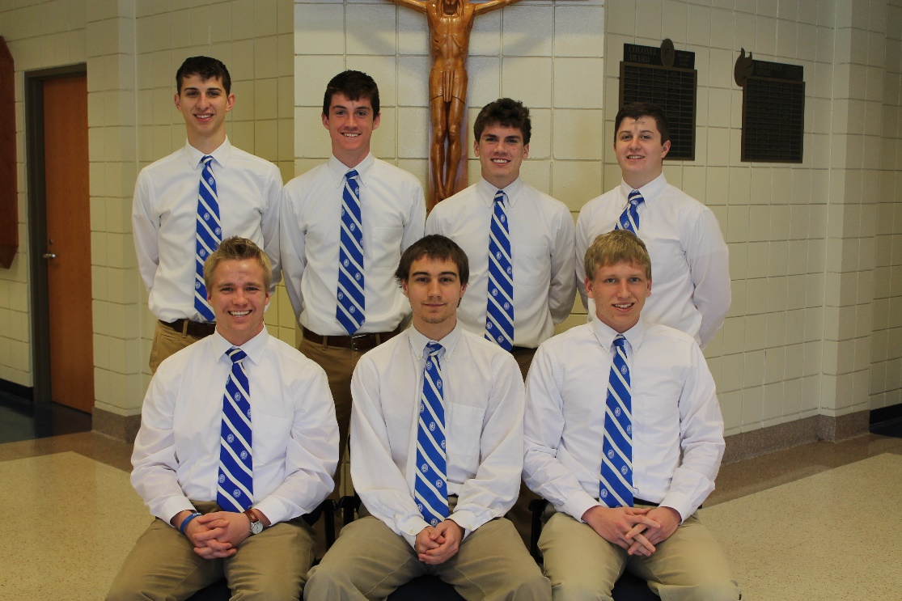

[Both Photos]
Front Row L to R: Lucas Timmerman, Peter Schaefer, Mitchell MacKnight.
Back Row L to R: Adam Flynn, Sean (Chris) Fagin, Benjamin Darpel, and Logan Boyle.

# # #

