FOR IMMEDIATE RELEASE  June 1, 2016 | 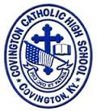
CONTACT:
Jill Franxman
Director of Marketing & Communications
Phone: (859) 448-2253
Email: jfranxman@covcath.org
Website: www.covcath.org
Facebook: www.facebook.com/CovCath

WILLIAMS FUND ANNOUNCES SCHOLARSHIP RECIPIENT
Covington Catholic senior Logan Boyle awarded $5,000

Logan Boyle, a 2016 graduate of Covington Catholic High School, was recently named the recipient of a $5,000 Williams Fund College Scholarship awarded by the Kenny and Brian Williams Fund. Ken Williams, Sr., who is on the board of directors for the fund named after his sons, his wife Kate, and David Thiel, Jr., also a member of the fund’s board of directors and a 1986 Covington Catholic graduate and classmate of Ken Williams, Jr. (“Kenny”), presented Boyle with the award.

The Kenny and Brian Williams Fund was founded by David Thiel and six other friends of the Williams brothers as a way to honor them after their tragic deaths. Kenny died in 1994 after falling from a Cincinnati skywalk. Brian died in the September 11, 2001 terrorist attacks on the World Trade Center. The brothers are Covington Catholic alumni who were known for their spirit, athleticism, academic excellence and zeal for life.

Logan Boyle is the son of Tim and Kathleen Boyle of Crescent Springs. He will attend the University of Notre Dame in the fall to study neuroscience. At Covington Catholic, he was the President of the National English Honor Society, the Vice President of the Magnified Giving Club, Captain of the Academic Team and TEAMS, and was recognized as the KUNA Outstanding Ambassador for 2015. He is a National Merit Finalist, scored a 36 on the ACT, and was a 2015 Kentucky Governor’s Scholar. In addition, he earned a varsity letter in Community Service all four years at Covington Catholic.

To be considered for the Williams scholarship, applicants submit essays explaining the reasons they value their Covington Catholic experience and deserve the award. The recipient is chosen for his academic performance, extracurricular participation and recommendations from faculty and administrators.

The Kenny and Brian Williams Fund also supports the Northern Kentucky-Greater Cincinnati community, particularly assisting those facing tragedies or having special needs. Since its inception, the Williams Fund has raised over $2 million. For more information, visit The Kenny and Brian Williams Fund website at kbwilliamsfund.org or the Covington Catholic website at www.covcath.org.

Covington Catholic High School is a Blue Ribbon of Excellence award winning college preparatory high school within the Diocese of Covington. It is an all-male school of 600 whose mission is to embrace the Gospel message of Jesus Christ in order to educate students spiritually, academically, physically and socially.

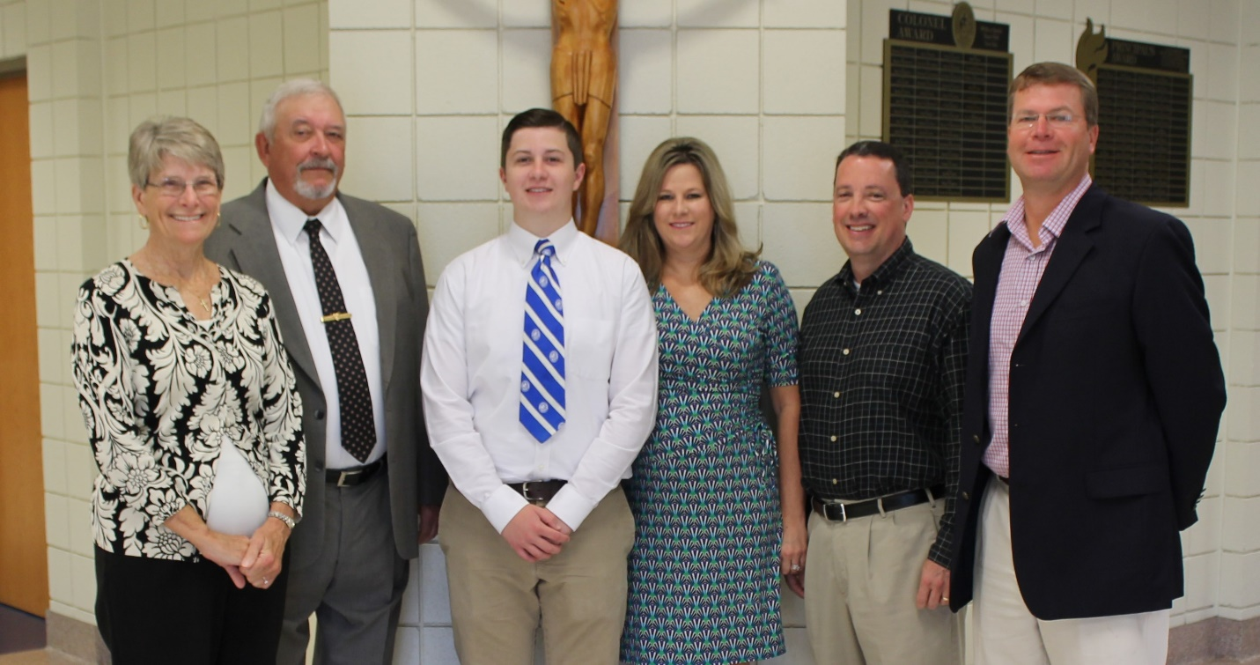
L to R: Mrs. Kate Williams, Mr. Ken Williams, Sr., Logan Boyle, Mrs. Kathleen Boyle, Mr. Tim Boyle, Mr. David Thiel, Jr.

# # #

