FOR IMMEDIATE RELEASE  October 11, 2016 | 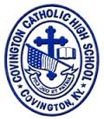
CONTACT:
Jill Franxman
Director of Business Operations & Marketing
Phone: (859) 448-2253
Email: jfranxman@covcath.org
Website: www.covcath.org
Facebook: www.facebook.com/CovCath

3 CCH Seniors Selected for NaviGo Lawyers Scholars Program
Inaugural Program established by NaviGo College and Career Prep Services

Three Covington Catholic Seniors have been selected to participate in the inaugural Northern Kentucky Lawyers NaviGo Scholars program. The students are: Kyle Crail, Aidan Donaghy, and Marcus Maier.
Selected Scholars will regularly meet with and receive coaching from a NaviGo Coach and local attorneys. This program is sponsored by Inn of the Courts, administered through the Northern Kentucky Education Council and services are provided by NaviGo, College and Career Prep Services, Inc. Selected Scholars will have the opportunity to work with dedicated professionals in the law profession and will be assisted and guided by a NaviGo Coach. Some of the attorneys who have contributed to the establishment of this program include: Penny Hendy, Kathleen Gormley-Johnson, Rob Sanders, Stephanie Dietz, Cathy Stavros and Jim West.
Covington Catholic High School was one of six schools selected to invite students to be part of the inaugural group, partially based on the success of the school’s first Mock Trial team in 2015-16.
The application to participate stated, "If you are thinking about a path to law school and are interested in exploring the legal profession by meeting with a variety of lawyers representing numerous areas of practice where a law degree is necessary (corporate counsel, personal injury and class action litigation, prosecuting attorney, criminal defense attorney, family law counsel, professors and Judges), and would like to learn from these experienced professionals about what their day to day job entails, apply to be considered for the inaugural Northern Kentucky Lawyers NaviGo Scholars Group!"
There is no cost to the schools, or to the selected students, for participating in this program. All coaching will take place at Thomas More College, NKU or local public offices. All coaching occurs after the school day, with all meetings occurring one-two times per month via 90-minute sessions beginning at 4:00 PM or later.
Mr. Tim Hanner, President of NaviGo College and Career Prep Services, met with the Covington Catholic students to tell them of their selection and to reinforce the expectations for and opportunities from the program. More information on NaviGo is available at: www.navigoprep.com or 859-905-7830.
Covington Catholic High School is a Blue Ribbon of Excellence award winning college preparatory high school within the Diocese of Covington. It is an all-male school of 597 whose mission is to embrace the Gospel message of Jesus Christ in order to educate students spiritually, academically, physically and socially.

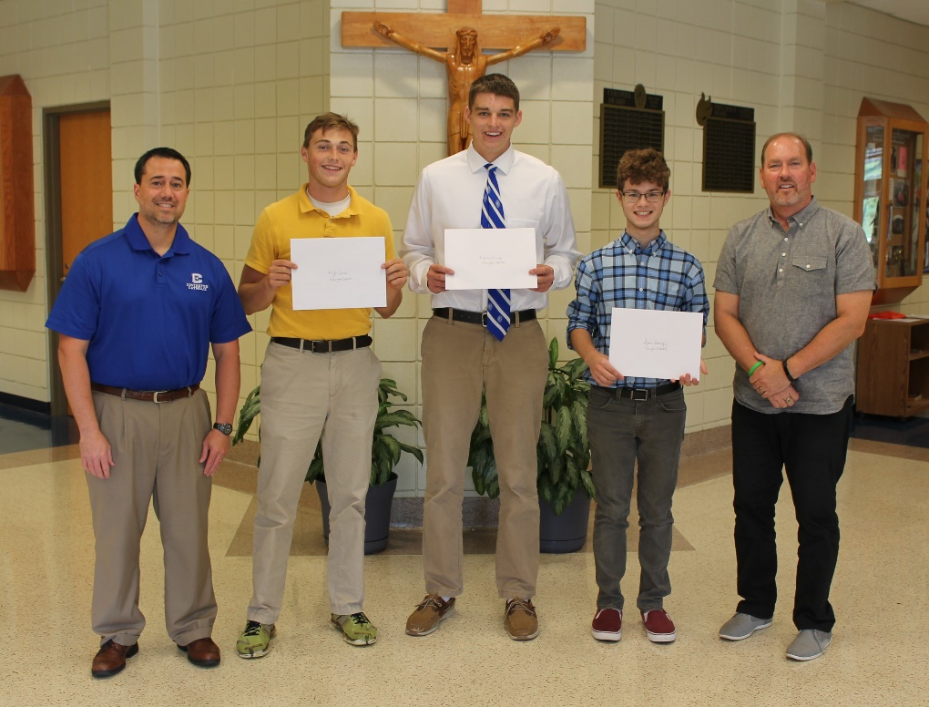
L to R: Mr. Tony Zechella (CCH Assistant Principal), Kyle Crail, Marcus Maier, Aidan Donaghy, Mr. Tim Hanner (President, NaviGo College and Career Prep Services).
# # #

