FOR IMMEDIATE RELEASE  September 25, 2015 | 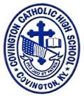
CONTACT:
Jill Franxman
Director of Business Operations & Marketing
Phone: (859) 448-2253
Email: jfranxman@covcath.org
Website: www.covcath.org
Facebook: www.facebook.com/CovCath

COVINGTON CATHOLIC HIGH SCHOOL
ANNOUNCES COMMENDED STUDENTS IN THE
2016 NATIONAL MERIT® SCHOLARSHIP PROGRAM

Covington Catholic is proud to announce that, in addition to the seven seniors recently recognized by the National Merit Scholarship Corporation as Semifinalists in the 61st annual National Merit® Scholarship Program, two Covington Catholic students received the Commended Student recognition. Last spring, roughly 1.5 million juniors in more than 22,000 high schools across the country entered the 2016 program by taking the PSAT/NMSQT Qualifying Test. Of those juniors, the 50,000 highest scorers are identified. 16,000 of them are designated as Semifinalists on a state representational basis, and have the opportunity to continue in the Merit Scholarship competition.
The other 34,000 high performers are now being named Commended Students as recognition of their exceptional academic promise. Although they will not continue in the 2016 competition for National Merit Scholarship awards, Commended Students placed among the top five percent of the more than 1.5 million students who took the Qualifying Test.
“The young men and women being named Commended Students have demonstrated outstanding potential for academic success,” commented a spokesperson for NMSC. “These students represent a valuable national resource; recognizing their accomplishments, as well as the key role their schools play in their academic development, is vital to the advancement of educational excellence in our nation. We hope that this recognition will help broaden their educational opportunities and encourage them as they continue their pursuit of academic success.”
The two CovCath seniors who have been named National Merit Commended Students (and the home parish and parents of each) are:
Nick Stegman | Blessed Sacrament | Gary and Traci Stegman
Sam Romes | St. Agnes | Timothy and Janelle Romes

Principal Robert Rowe commented, “Our administration and faculty, and the Covington Catholic community are very proud of these students on being named National Merit Commended Students. This is a highly significant achievement for these students and we congratulate them. Covington Catholic High School takes great pride in our academics as illustrated by our consistently high ACT scores and educational accolades, but more importantly, we are proud of the well-rounded community leaders we produce.”
Covington Catholic High School is a Blue Ribbon of Excellence award winning college preparatory high school within the Diocese of Covington. It is an all-male school of 604 whose mission is to embrace the Gospel message of Jesus Christ in order to educate students spiritually, academically, physically and socially.

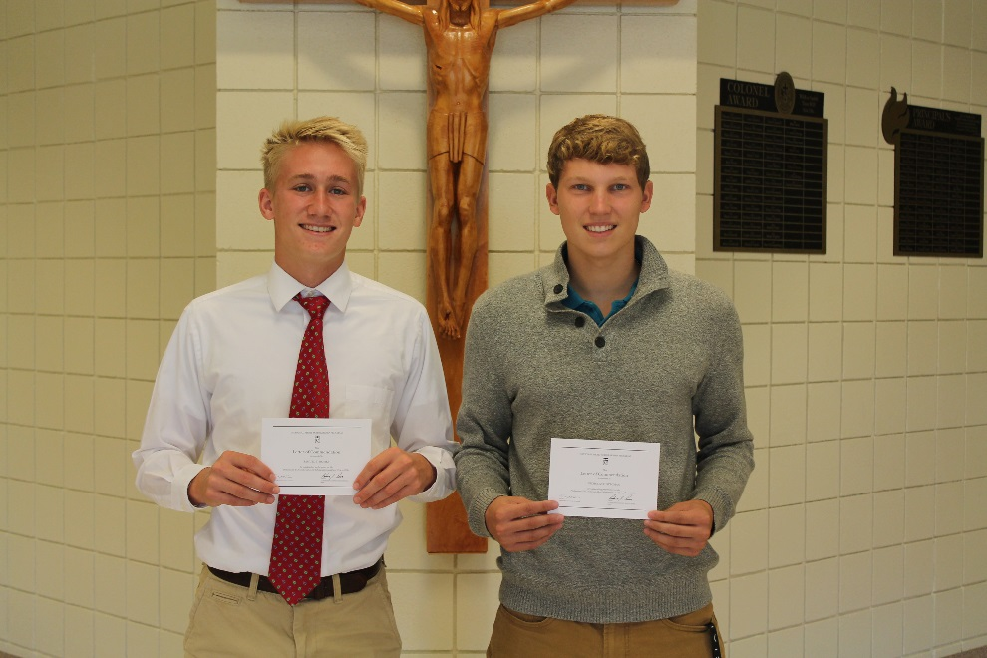

L to R: Sam Romes, Nick Stegman

# # #

