FOR IMMEDIATE RELEASE  September 9, 2015 | 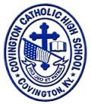
CONTACT:
Jill Franxman
Director of Business Operations & Marketing
Phone: (859) 448-2253
Email: jfranxman@covcath.org
Website: www.covcath.org
Facebook: www.facebook.com/CovCath

COVINGTON CATHOLIC HIGH SCHOOL
ANNOUNCES SEVEN NATIONAL MERIT SEMIFINALISTS

Covington Catholic, a Blue Ribbon School, is proud to announce that seven seniors have been recognized by the National Merit Scholarship Corporation as Semifinalists in the 61st annual National Merit® Scholarship Program. Last spring, roughly 1.5 million juniors in more than 22,000 high schools across the country entered the 2016 program by taking the PSAT/NMSQT Qualifying Test. Of those juniors, only 16,000, or about 1%, were named National Merit Semifinalists, based on their scores on this exam. These academically talented students now have an opportunity to continue in the competition for some 7,400 scholarships worth more than $32 million that will be offered in the spring of 2016. About 90 percent of the Semifinalists are expected to attain Finalist standing, and about half of the Finalists will win a National Merit Scholarship, earning the Merit Scholar® title.
The seven CovCath seniors who have been named National Merit Semifinalists (and the home parish / parents of each) are:
Logan Boyle | St. Joseph Crescent Springs | Tim and Kathleen Boyle
Benjamin Darpel | St. Pius X | Paul and Cheryl Darpel
Sean (Chris) Fagin | St. Timothy | Sean and Laura Fagin
Adam Flynn | St. Agnes | Kevin and Jackie Flynn
Mitchell MacKnight | St. Pius X | David and Gretchen MacKnight
Peter Schaefer | St. Joseph Crescent Springs | Jack and Maria Schaefer
Lucas Timmerman | Immaculate Heart of Mary | Jerry & Jennifer Timmerman

Principal Robert Rowe commented, “Our administration and faculty, and the Covington Catholic community are extremely proud of these seven students on being named National Merit Semifinalists. Every one of these young men are exceptional students with a diligent work ethic. Covington Catholic High School takes great pride in our academics as illustrated by our consistently high ACT scores and educational accolades, but more importantly, we are proud of the well-rounded community leaders we produce.”
Covington Catholic High School is a Blue Ribbon of Excellence award winning college preparatory high school within the Diocese of Covington. It is an all-male school of 604 whose mission is to embrace the Gospel message of Jesus Christ in order to educate students spiritually, academically, physically and socially.

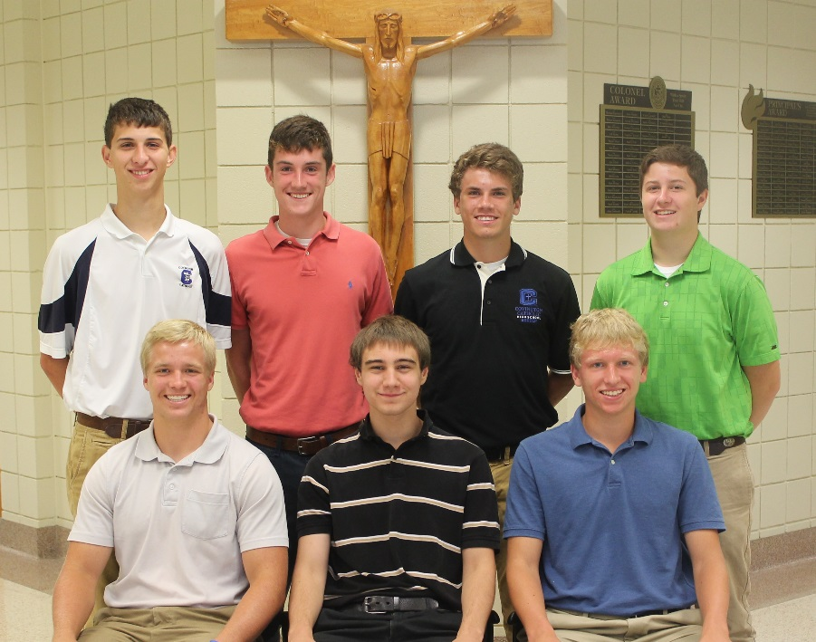

Front Row L to R: Lucas Timmerman, Peter Schaefer, Mitchell MacKnight.
Back Row L to R: Adam Flynn, Sean (Chris) Fagin, Benjamin Darpel, and Logan Boyle.

# # #

