FOR IMMEDIATE RELEASE  September 3, 2015 | 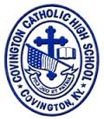
CONTACT:
Jill Franxman
Director of Business Operations & Marketing
Phone: (859) 448-2253
Email: jfranxman@covcath.org
Website: www.covcath.org
Facebook: www.facebook.com/CovCath

COVINGTON CATHOLIC HIGH SCHOOL ANNOUNCES
THE ESTABLISHMENT OF ARLINGHAUS FAMILY SCHOLARSHIP

Covington Catholic High School announces the establishment of The Art and Rita Arlinghaus Family Scholarship to provide financial assistance for young men to attend CovCath. This endowment was created by the family, which includes numerous alumni and future students of CovCath, in honor of their parents. The school is very grateful for this generous support.

As long-time Northern Kentucky residents and active community members, Rita and her late husband Art raised seven children, five of whom graduated from Covington Catholic - Ronald (CCH Class of 1967), Ken, Terry (1972), Dale (1974), Mark (1978), David (1980), and Mary Jean Klein. In addition, eleven of their grandsons have graduated or will graduate from Covington Catholic.

Rita Arlinghaus stated, “I’m just so proud to be a part of the Covington Catholic community. My husband, Art, was a big proponent of Catholic education. Fourteen of the boys, both sons and grandsons, have attended CCH with a couple more still to come. It’s wonderful to see the tradition continue with all of the boys from the second generation wanting to attend.”

“My family feels strongly about the value of a Covington Catholic education. We want to make sure that current and future students can attend Covington Catholic.”

Covington Catholic High School is a Blue Ribbon of Excellence award winning college preparatory high school within the Diocese of Covington. It is an all-male school of 604 whose mission is to embrace the Gospel message of Jesus Christ in order to educate students spiritually, academically, physically and socially.

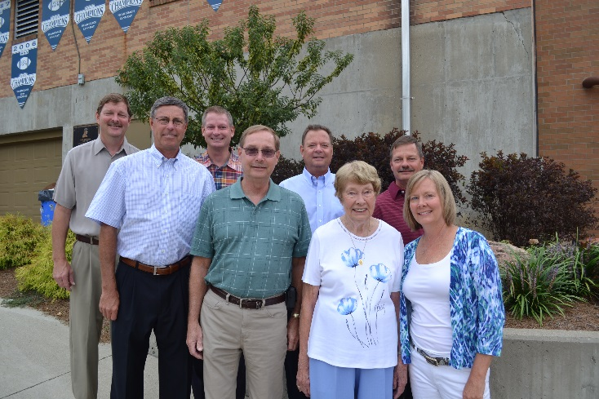

Photo (L to R): David (1980), Ken, Mark (1978), Ronald (1967), Terry (1972), Rita, Dale (1974), and Mary Jean Klein.

# # #

